**Philadelphia Freedom Chorus for Extreme Sweet Adelines**

**2016 Regional Convention Guide**



***IN A NUTSHELL***

Here are the highlights for PFC’s convention weekend:

1. Friday at 12:33pm, Melissa & Heather compete with Sweet Lucy in Region 4. We will meet in the lobby near the Great American Hall to huddle around an iPad or two to watch the webcast.
2. Friday Afternoon at 1:20 pm, we have our Stage Walk On in the Great American Hall.
3. From 2:00-4:00pm on Friday, we will rehearse at Church of the Redeemer (500 W. Chocolate Ave, Hershey, PA 17033). We will finish in time to get to the quartet contest when it starts at 5pm. The church is a 4 minute drive from the Hershey Lodge right on Rt 422 (Chocolate Ave).
4. Saturday at 9:45AM, we meet in the Wild Rose 2 ballroom at the Hershey Lodge for a 30-minute rehearsal.
5. Saturday at 11:11 am, stage-ready, we will meet in the Lobby of the Hershey Lodge to begin the traffic pattern. Our onstage time is 11:36 am.
6. Saturday after the Chorus Contest (5:30ish), we meet in Jennifer & Barb’s room for a Review of Scoresheets!
7. Saturday night after the Show of Champions, JoAnn & MB’s room will be open for socializing. Make sure to stop by the regional party and check out a few hospitality suites!

Be where you need to be, with whom you need to be with, and worry not about expectations of constant togetherness. At the core of our values are trust and openness, and I trust that everyone will be responsible for her role in the ensemble.

Our only expectation of you is that you make smart decisions that support our goals and allow you to enjoy yourself and the contest weekend experience.

**We ARE PFC!!! We ARE Sweet Adelines!!!**

Dear PFC,

I am very excited to be standing in Melissa's shoes for PFC's 2016 competition performance. It is the best seat in the house! Thank you all for the honor and the trust you have placed in me to help guide the development of our package. I think we will present two delightful musical stories to Region 19, of which we can be proud.  
  
In the almost 20 months I've been with you on your extreme musical journey, I've learned that a positive attitude in rehearsal reaps giant benefits, that homework by all can actually be an expectation, that individual criticism in front of others can be tolerated and even encouraged for the benefit of the group, and that size really doesn't matter! Keep hydrating and I'll see you all in Ocean City! (Lol, guess I'd better get that limo...)  
  
Cyd

What an incredible journey we have shared together to bring us to this much anticipated 2016 Regional Competition.  I am so very grateful for the opportunity to serve this fine group of talented performers as your musical leader.  I am so very grateful for the support and service Cyd has contributed in coming out front.  And, I am proud to see the chorus rally through a period of change and uncertainty.

Most importantly -  I am so very grateful for each and every member of PFC.  Each of us contribute an essential part of the picture.  It is a delicate balance.  It's not just the musical product that relies on our energy and focus.  The community of PFC relies on every member and her participation.  I thank you for every thread you have woven to this beautiful fabric - for all of the colors and fibers are what make us uniquely PFC.

I am confident the 2016 Regional Competition experience will be memorable, and my personal wish for everyone is for an experience filled with joy and pride.

Melissa

***CREATE YOUR OWN SCHEDULE OF EVENTS***

When you get to Hershey, be sure to go to the convention registration to pick up your registration package (including All Events Badge) and the Convention Schedule. This will include start times for all the events, and the order of contestants for the Quartet and Chorus competitions. Compare notes with your various commitments, and use this planner to create your own schedule for the weekend. Included below are the items in PFC’s schedule – and a few other key activities for our quartet & dual members. The rest is up to you!

**FRIDAY, APRIL 24, 2015**

|  |  |  |
| --- | --- | --- |
| **Time** | **Activity** | **Location** |
| 9:15 | Inspection Quartet sound set up (Jenn, JoAnn) | Great American Hall |
| 10:30 | Quartet briefing check in  (Jenn, Patti) | Great American Hall  Back of the middle front audience section |
| 11:00-11:45 | Jersey Sound Riser Rehearsal  (Maggie) | Wild Rose 1 ballroom |
| 11:45 | Chorus Briefing for Directors & Team Leaders  (Jenn, Cyd) | Great American Hall  Back of the middle front audience section |
|  |  |  |
| 12:33 | Sweet Lucy on stage in Region 4 | Lobby of the Hotel |
| **1:20** | **PFC Stage Walk On** | **Great American Hall** |
| **2:00-4:00** | **PFC rehearsal** | **Church of the Redeemer**  **500 W. Chocolate Ave,**  **Hershey, PA 17033** |
| 2:20 | Jersey Sound Stage Walk On  (Maggie) | Great American Hall |
|  |  |  |
|  |  |  |
| 5:00 – 10:00 pm | Quartet Contest | Convention Center |
|  | 5:00 PM | Sound Design on stage |
|  | 7:30 PM | MP4! on stage |
| After contest | PoB & Greater Harrisburg riser rehearsals  (Cyd, Maggie, Nancy) | Wild Rose 1 ballroom (PoB), Great American Hall (GH) |
|  |  | |

**SATURDAY, APRIL 25, 2015**

|  |  |  |
| --- | --- | --- |
| **Time** | **Activity** | **Location** |
|  |  |  |
| **9:45-10:15 AM** | **PFC Rehearsal** | **Wild Rose 2 ballroom** |
| **11:11 am** | **PFC Traffic Pattern** | **Lobby @ 11:11; on Stage 11:36** |
|  | Enjoy the contest and await results! | Great American Hall |
| 12:30-1:00 | Jersey Sound Riser Rehearsal  (Maggie) | Wild Rose 1 ballroom |
|  |  |  |
| 2:00-3:00 | PoB Riser Rehearsal  (Cyd) | Wild Rose 2 ballroom |
| 2:44 pm | Jersey Sound on Stage –  Go Maggie!! |  |
| 4:08 pm | Pride of Baltimore on Stage  Go Cyd |  |
| **5:30 pm** | **PFC Review of Scoresheets Briefing for our evening plans** | **Jenn & Barb’s room** |
| **8:00 pm** | **Show of Champions** | **Great American Hall** |
| **Later…** | **Region 19 Afterglow &**  **PFC Hospitality Suite** | **MB & JoAnn’s room** |

**HOTEL**

**HERSHEY LODGE -** 325 University Dr. Hershey, PA 17033

Tel: (717) 533-3311 Website: <http://www.hersheylodge.com>

Check In Time: 4:00 PM Check Out Time: 11:00 AM

Room types available are 1 King bed or 2 Queen beds. There are no suites available. PLEASE NOTE! You cannot be guaranteed a room with two queen beds. Every effort is made to meet your requests, but rooms with two beds will go first to those with more than two people in a room.

Please specify on the housing form if you need a handicap room.

Personal checks are not accepted by the Hershey Lodge for payment of housing. Credit cards accepted: MasterCard, VISA, American Express, Discover and Diners Club

Room fees may be divided among guests by the hotel at check in or check out. Hotel cancellation policy is 3 days before your arrival date. All changes or cancellations must go through Marie Decker, Housing Coordinator. If you must cancel a room, it must be done 3 days in advance of your scheduled arrival date or the hotel will charge your credit card for 1 night's lodging.

Based on hotel room occupancy on Thursday night, rooms cannot be guaranteed to be ready on Friday until the 4:00 PM published check in time. The hotels will make every effort to have rooms ready as soon as possible. However, checkout time is 11:00 AM for departing guests and all rooms must then be cleaned. If you plan to arrive before 4:00 PM, and if your assigned room is not ready, the hotel CANNOT change room assignments. There will be a place provided for you to store your luggage, so you may attend the scheduled activities until your room is ready.

All rooms at the Hershey Lodge have complimentary Wi-Fi, a refrigerator, flat screen TV, iPod alarm clock, iron and ironing board, safe, and hair dryer.

There is free self-parking available and valet parking for $18 per night.

**Directions to Church of the Redeemer**

* Head South (turn RIGHT) on University Drive towards Briarcrest Dr. (217 ft)
* Turn LEFT at the 1st cross street onto Briarcrest Dr. (.5mi)
* Turn LEFT onto W Areba Ave (0.3mi)
* Turn LEFT onto Hockersville Rd (0.1mi)
* Turn RIGHT onto W. Chocolate Ave (0.3mi) – Church is on the Right

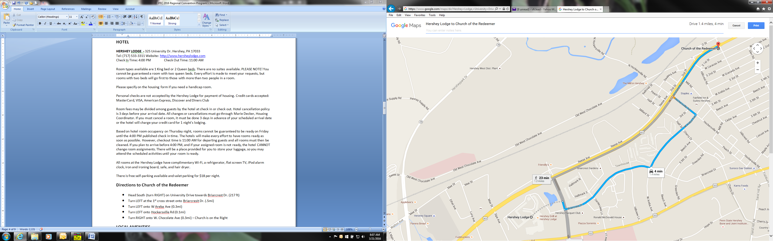

**LOCAL AMENITIES**

**Restaurants**

There are several restaurants at the Hershey Lodge. None of the restaurants will take reservations. They are on a first come, first served basis.

* Hershey Grill: Breakfast, Lunch, Dinner
* Forebay: Dinner
* Bear’s Den: Lunch, Dinner
* Lebbie Lebkichers: Breakfast
* Cocoa Beanery: Coffee shop with sandwich selection

**JUDGING PANEL**

**Sound** – Dale Syverson **Music** – Jan Meyer

**Expression** - Paula Davis (Panel Chair) **Showmanship** - Ruth Ann Parker

**Panel Secretary** – Andrea Hass

**WHAT TO WEAR**

**CHEER WEAR**

What is cheer wear? It’s a great way to express your own personal style while creating a unifying look for PFC. With a few common elements, every member can express her individual style while still participating in a “branded” look. Cheer Wear is encouraged anytime when you are not in costume. It’s a simple combination of elements:

* LOVE pin
* Name badge
* Any combination of royal blue, white, black, silver and denim clothing and accessories.

When in doubt, dress up (not down). The effect is enhanced when you combine multiple colors, textures and accessories. Bling is encouraged! As an ambassador of PFC, think about how you present yourself to convey a **positive, polished,** and **professional** image. Dress to impress and you will attract people to you.

**STAGE READY**

When you see references to “stage ready”, the expectation is that you are fully dressed for stage, including complete make-up, hair styled, etc. Our stage ready ensemble includes the following:

* Opaque Black Hosiery (solid black, can’t see thru it) & Full coverage foundation undergarments
* Black & Bling outfit approved by Robin C.
* Blingy jewelry (Rhinestones, shiny pieces)
* Black Shoes
* Full make-up complete & hair styled in a dressy, sophisticated look
* Nails in French Manicure or clear gloss top coat
* Small personal items (including lipstick) and All-Events Badge packed up & ready to go!
* A winning smile and a positive attitude!

**HAIR**

Go for **lift** and **volume** – maximize your style by sweeping hair up off the forehead and showing as much of your face as possible. Go for a dressier look than your day-to-day style. The hairstyle we take on stage should be glamorous. Imagine YOUR face is the one on the cover of the Pitch Pipe magazine! Use volume to create the illusion of height for your hairstyle. Secure your style with plenty of hairspray. For hair styling tips and ideas, there are numerous instructional videos posted on Youtube.

**MAKE-UP CHECKLIST**

* Foundation: Ben Nye Lite Chinese
* Translucent Powder: any kind – a Must!
* Eye Shadow: Revlon Colorstay Neutral Khakis - lightest (bone) and darkest (purple/brown)
* Lipstick: Ben Nye True Red
* Blush: Ben Nye Victorian Rose
* Mascara: any kind – Black
* Eyeliner: any Kind – Black
* Eyebrow Pencil: any kind – to enhance your natural color
* False Eyelashes: any Kind - recommend Ardell #116 or 110
* Applicator brushes and sponges (round ones are better than triangles for smooth foundation)
* Hand mirror
* Personal facecloth (to spare the hotel the mess of using theirs!)

***MAKE-UP APPLICATION INSTRUCTIONS***

**Base:** Using a large sponge make-up applicator (the round ones are the best), completely cover your face (including eyelids), neck and collarbone are of your upper chest with foundation. Apply generously to get smooth coverage. Check your application in natural light (go to the window with your hand mirror), checking earlobes and behind your ears if you have shorter hair, or are wearing your hair up. When finished, apply translucent powder to set the foundation. This will tone down the foundation a bit, but more importantly, this will be the “shine-stopper” on stage.

**Eyes: When your base is complete, move on to your eyes to create the drama! A f**oam-tipped applicator will give the most exact lines - or a short bristle stiff brush like an eyeliner brush. Follow these steps for show-stopping, expressive eyes! See the photo below for a look at the finished product.

1. Apply the dark purple/brown eye shadow to the socket, to create a “socket shadow.” Lift the eyebrows and feel for the edge of the eye socket, brushing the shadow along it in a roundish curve to give a hard line of purple/brown color. If you can’t see it when you look in the mirror, it is too low on the eye socket and has disappeared into the crease of the lid. When you open your eye, you should see the line of shadow slightly higher than your eyelid. You can blend the dark shadow down to the edge of your eye if you want to.
2. Apply the lightest bone shade to the lid, inner corner and below your eyebrow.
3. The lines of shadow should be very exact and crisp, and not blurry. They should not blend with each other. The job of stage eye shadow is to accentuate our eyes ON STAGE, not look like everyday eye shadow. Trust me, they’ll look very weird up close, and totally natural on the stage.
4. **Eyeliner:** If you use a pencil, as opposed to liquid, warm it up by rubbing across top of hand. I always suggest liquid liner however, for the crispness of it - and there are a few felt tip waterproof black eyeliners that are good (Wet & Wild and Stila).
   1. Apply 7/8ths the length across the top of the lid, almost to the edges, but not quite, then add an "eyelash" at the outside, curving up slightly.
   2. 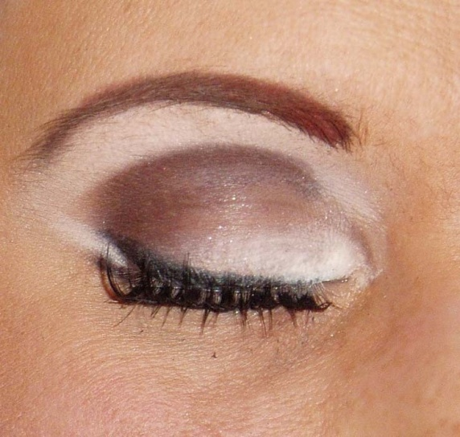On the bottom line the outside 1/4 or 1/3, from just outside the pupil to the edge, and add a small "eyelash" curving slightly down.
5. Add the bone shadow between the two added "eyelashes" at the corner of the eye, also to the inside corner, and to just under eyebrows.
6. Gently fill in eyebrows with pencil to darken.
7. Apply false eyelashes on top lashline if desired. Apply using a small line of glue, blow on it for a few seconds to make it tacky, and then press lashes into place. You might want to re-eyeliner over the glue once it sets.
8. If you aren’t using false eyelashes, apply lots of mascara to the top lashes.
9. Apply mascara to the bottom lashes.

**Lips:** Completely cover your lips with liner before applying lipstick. Apply lipstick and check in the mirror – sing “AH” and check that the corners of your mouth are covered in lipstick – touch up to complete a full circle of color.

**Blush:** Liberally apply blush to cheeks to complete the look!

**Nails:** French manicure or colorless with a glossy clear coat on top (see Cyd if you have a conflict with another competing group).

**CONTACT**

**IF YOU HAVE SMARTPHONE, BE SURE YOU’VE DOWNLOADED THE  APP AND JOINED THE PFC GROUP!**

|  |  |  |  |
| --- | --- | --- | --- |
| Top of Form  **Full name**  Bottom of Form | **E-mail** | **Mobile phone** | **Room** |
| Carberry, Robin | [rcsongbird@hotmail.com](mailto:rcsongbird@hotmail.com) | 609-618-7592 |  |
| Carfolite, Barb | [nmlead@aol.com](mailto:nmlead@aol.com) | 610-357-0243 |  |
| Dalessandro, Marybeth | [mbdsings.tenor2@verizon.net](mailto:mbdsings.tenor2@verizon.net) | 215-350-1914 |  |
| DePaul, Carol | [sacarol@ptd.net](mailto:sacarol@ptd.net) | 717-271-2663 |  |
| Donapel, Maggie | [maggie@maggiedoodles.com](mailto:maggie@maggiedoodles.com) | 215-837-1886 |  |
| Falcone, Donna | [barifem@aol.com](mailto:barifem@aol.com) | 267-872-2294 |  |
| Keefer, Dottie | [dottiekeefer@yahoo.com](mailto:dottiekeefer@yahoo.com) | 215-595-6065 |  |
| Kelly, Cheryl | [cerkkss@yahoo.com](mailto:cerkkss@yahoo.com) | 267-242-7367 |  |
| Kern, JoAnn | [jobaritone@yahoo.com](mailto:jobaritone@yahoo.com) | 215-262-3425 |  |
| Mathews, Robin | [matfamq@comcast.net](mailto:matfamq@comcast.net) | 215-859-8707 |  |
| Newman, Jennifer | [vfclead@yahoo.com](mailto:vfclead@yahoo.com) | 610-659-0096 |  |
| Richardson, Irene | [acappellalady@hotmail.com](mailto:acappellalady@hotmail.com) | 443-417-7235 |  |
| Robie, Helen | [hrobie@comcast.net](mailto:hrobie@comcast.net) | 267.987.6355 |  |
| Saul, Nancy | [nifty516@aol.com](mailto:nifty516@aol.com) | 609-903-7957 |  |
| Sengstacke, Diane | [hometitle@hotmail.com](mailto:hometitle@hotmail.com) | 410-790-1451 |  |
| Swantek, Pat | [irishmiss1@comcast.net](mailto:irishmiss1@comcast.net) | 215-920-0855 |  |
| Tironi, Patti | [ptironi@trane.com](mailto:ptironi@trane.com) | 908-246-6482 |  |
| Trudeau, Chris | [justducky422@aol.com](mailto:justducky422@aol.com) | 610-883-3728 |  |
| Wentsel, Cydney | [cswentsel@gmail.com](mailto:cswentsel@gmail.com) | 410 937 1749 |  |