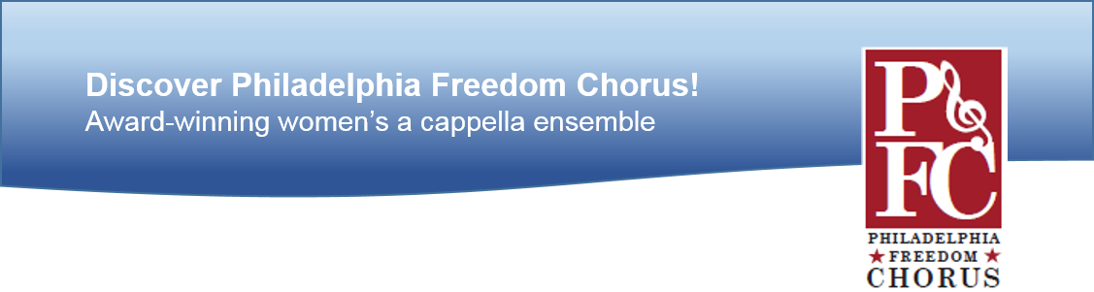

**WELCOME TO PHILADELPHIA FREEDOM CHORUS!**

PFC is a chartered Chapter of **Sweet Adelines International**, an independent, non-profit music education association, and one of the world's largest singing organizations for women. We sing 4-part, acapella arrangements in a mix of old standards, and more contemporary songs.

Our membership includes women in the immediate area, but also coming from other parts of PA, DE, MD, and NJ.

Currently, we meet online, via ZOOM, every Sunday from 1-3pm, with necessary adjustments for holidays. When we can gather physically, we will rehearse from 1 – 5pm, “every other” Sunday.. The musical culture of PFC emphasizes personal responsibility in being prepared for every rehearsal, in order to maintain and build upon our skills levels.

Any woman who enjoys singing is welcome to audition for membership. Formal training or the ability to read music is not required. We request that you visit at least three times prior to auditioning; we want you to be sure that our group is right for you!

Please feel free to contact our Membership Chair with any questions that you may have between now and our next session. Email Lori Schneider at [raidergreen@yahoo.com](mailto:raidergreen@yahoo.com) or call 610-389-4587.

**THANK YOU FOR SHARING YOUR DAY WITH US!**